Cummins Programming

1. get ESN

2. look up ESN on https://parts.cummins.com/

3. type in ESN at top
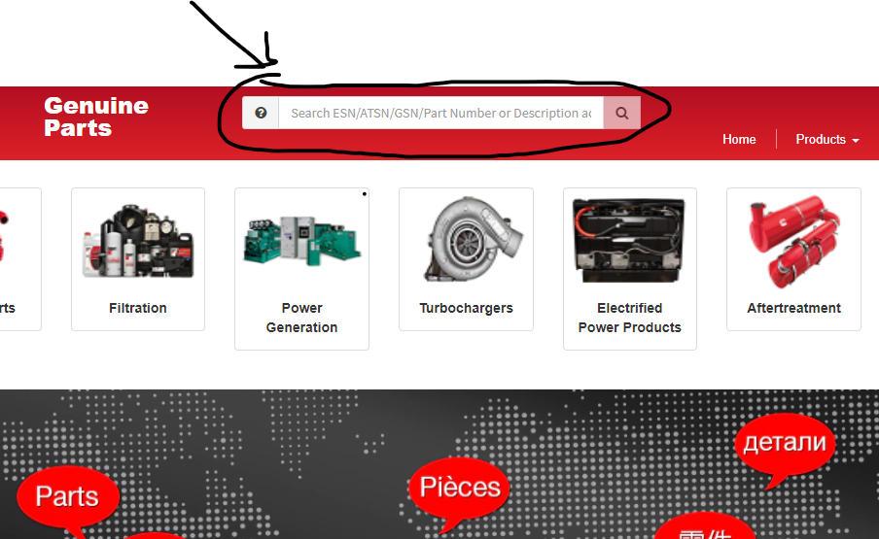

4. click on option view on left hand side of window
- IF ISX or ISB or any other IS? You MUST GET ECM CODE

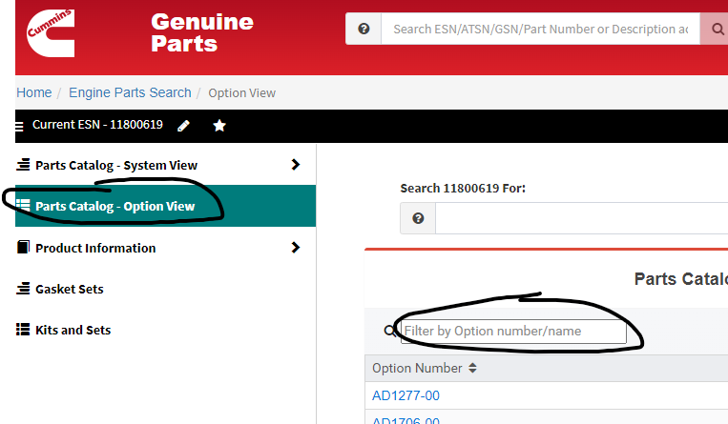

ISX ECM CODE IS IN product information section

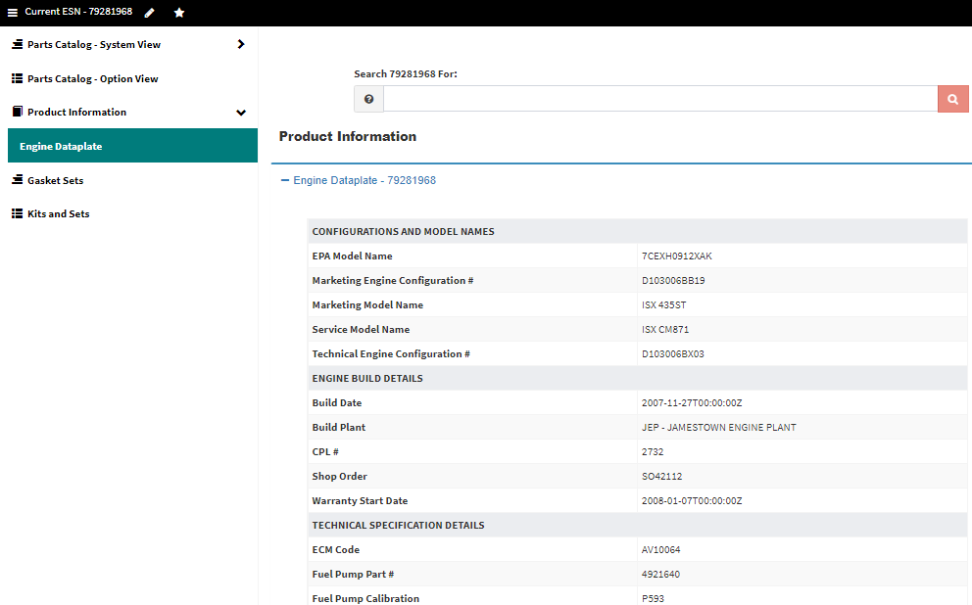
5. in the filter by Option Number/Name area you will search for SC
- SC – write down SC number
  - if it is blue click on it and write down CPL if available
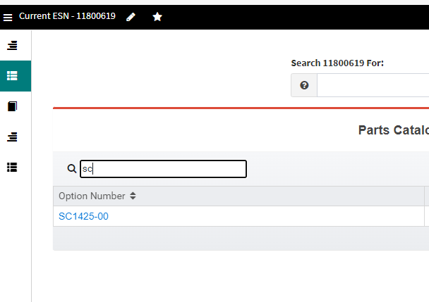

6. in the filter by Option Number/Name area you will search for DO
- DO – write down DO number
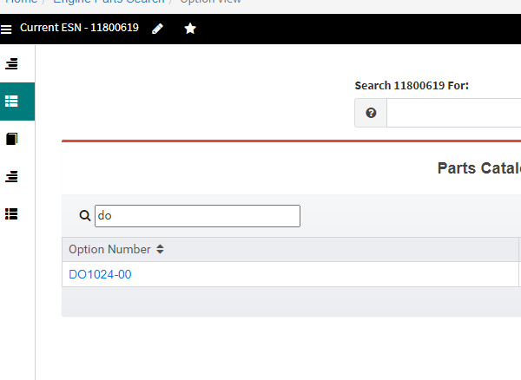

7. in the filter by Option Number/Name area you will search for module
- Module - look for engine control module partnumber
- click all blue options until you get a diagram with ECM on it
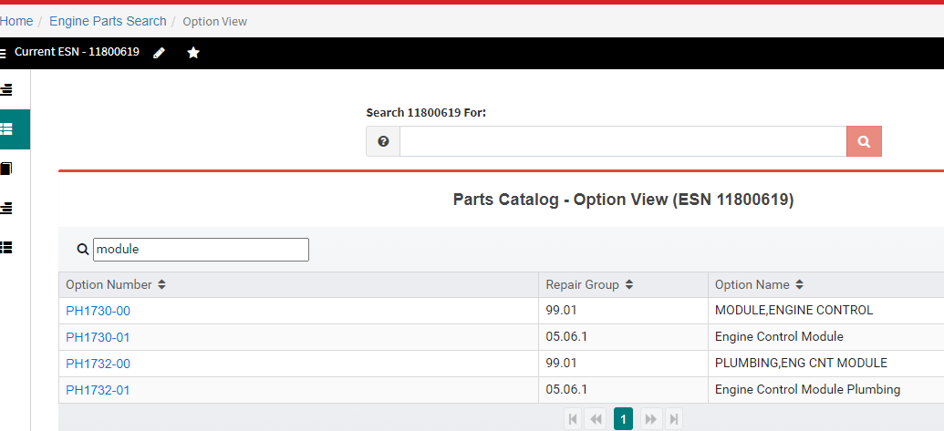

ECM diagram example:

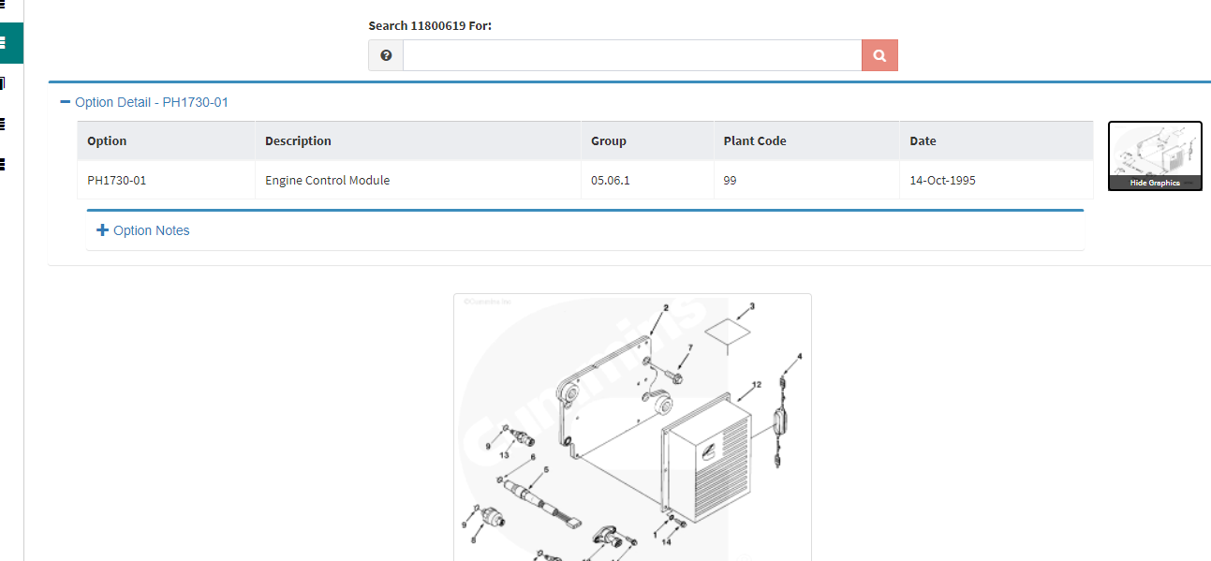

8. open cummins insite and connect to ECM

connect to ecm button
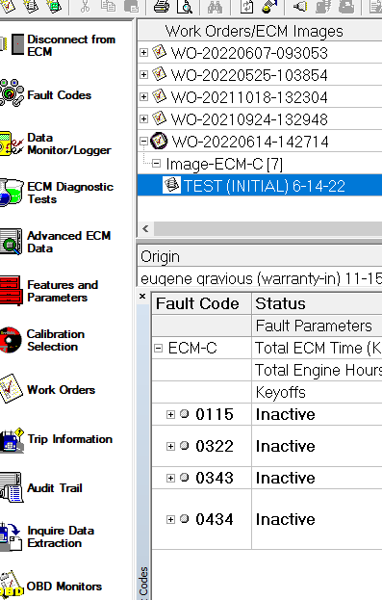

9. click calibration selection
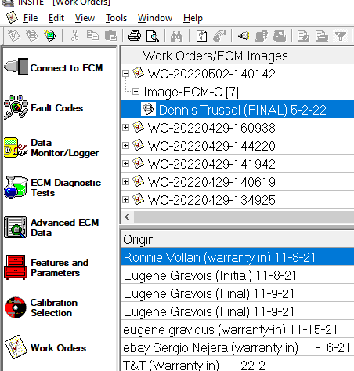
- select engine type and ECM partnumber

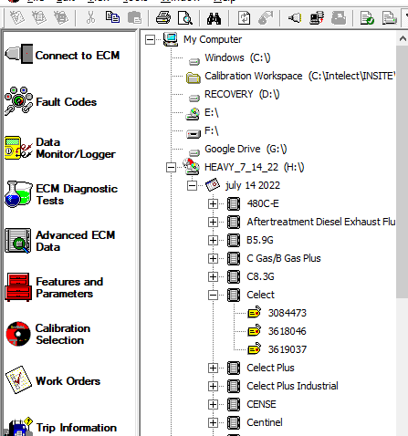

- select calibration according to SC, CPL, DO and Horsepower using drop downs or IF ISX USE THE ECM CODE
  - if SC does not give you correct programming for the horsepower customer request

  - use CPL to filter out engines
    - CPL must match the one for engine if necessary use SC number to see what CPL is selected then keep filtering without the SC
  - then use Horsepower
    - use max governed speed

- once you have filtered out calibrations send to ecm by right clicking on it and selecting transfer to ecm
  - only calibrations with green check mark are available so when multiple are left only the green one can be sent
